KCH6N -

Functionality
The standard hierarchy is a tree structure that contains all profit centers in a controlling area and reflects the organizational structure used in Profit Center Accounting.

Scenario
Using this transaction in order to display a Profit Center “1116”.

Requirements
A Standard hierarchy should exist.

Menu Path | Accounting → Controlling → Profit Center Accounting → Master Data → Standard Hierarchy → KCH6N - Display
Transaction Code | KCH6N

1. Double Click on KCH6N – Display.

Standard hierarchy for profit centers Display

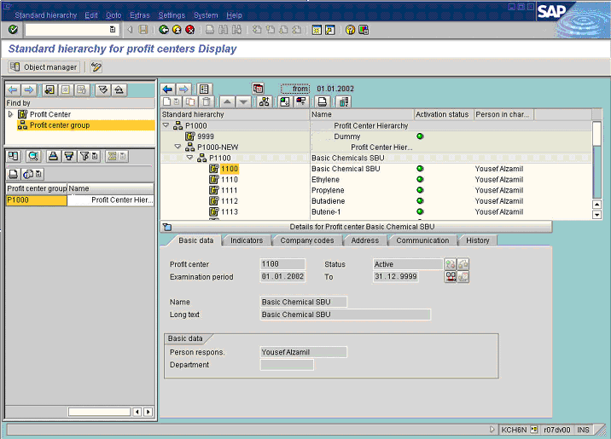

2. Select treeview node P1100.

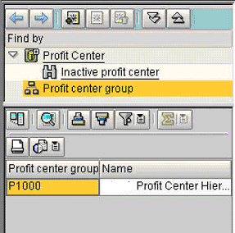

3. Select treeview node Profit Center.
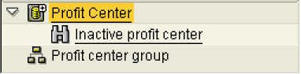

Find Profit center

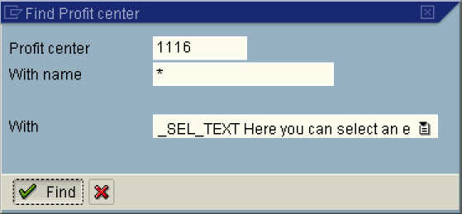

4. Click * Button .

5. Update the following fields:

Field Name | Field Description | Values
Profit center | Code of profit center to be found. | Example: 1116

6. Click Find Button .

Standard hierarchy for profit centers Display

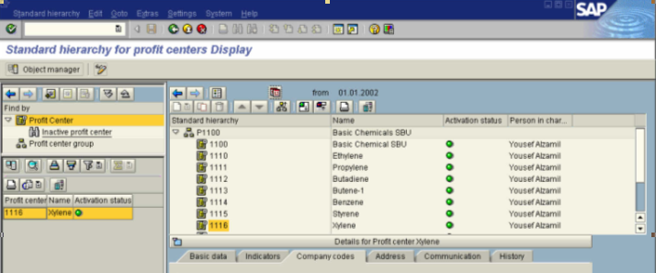

7. Select 1116 - Xylene in list box.

8. Select treeview node 1116.
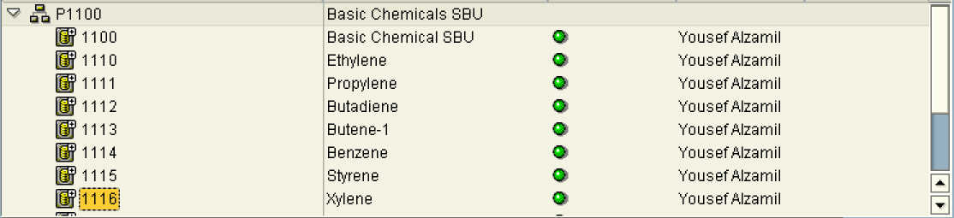

9. Click <tab button> Basic data .

Standard hierarchy for profit centers Display

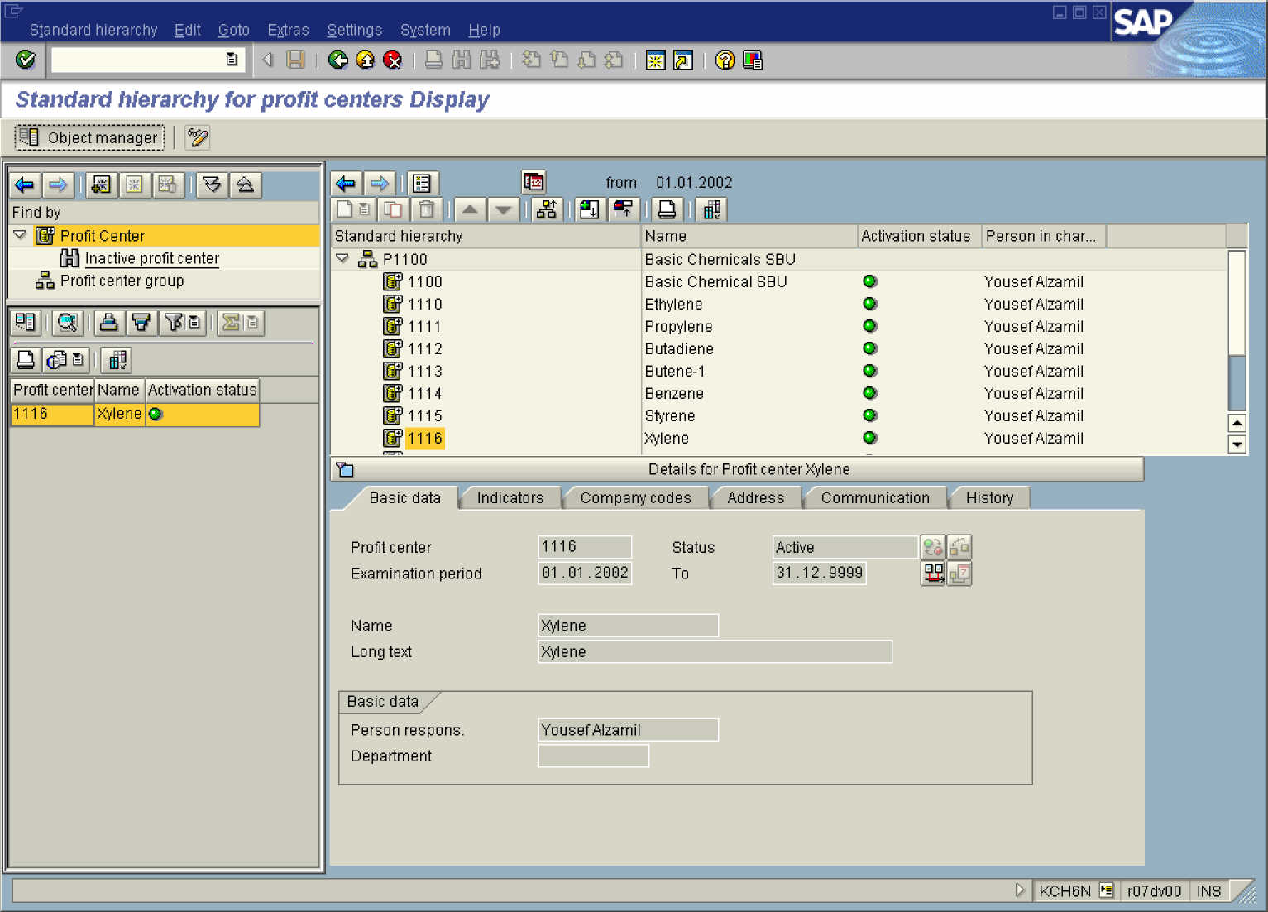

10. Click Object manager Button .

Standard hierarchy for profit centers Display

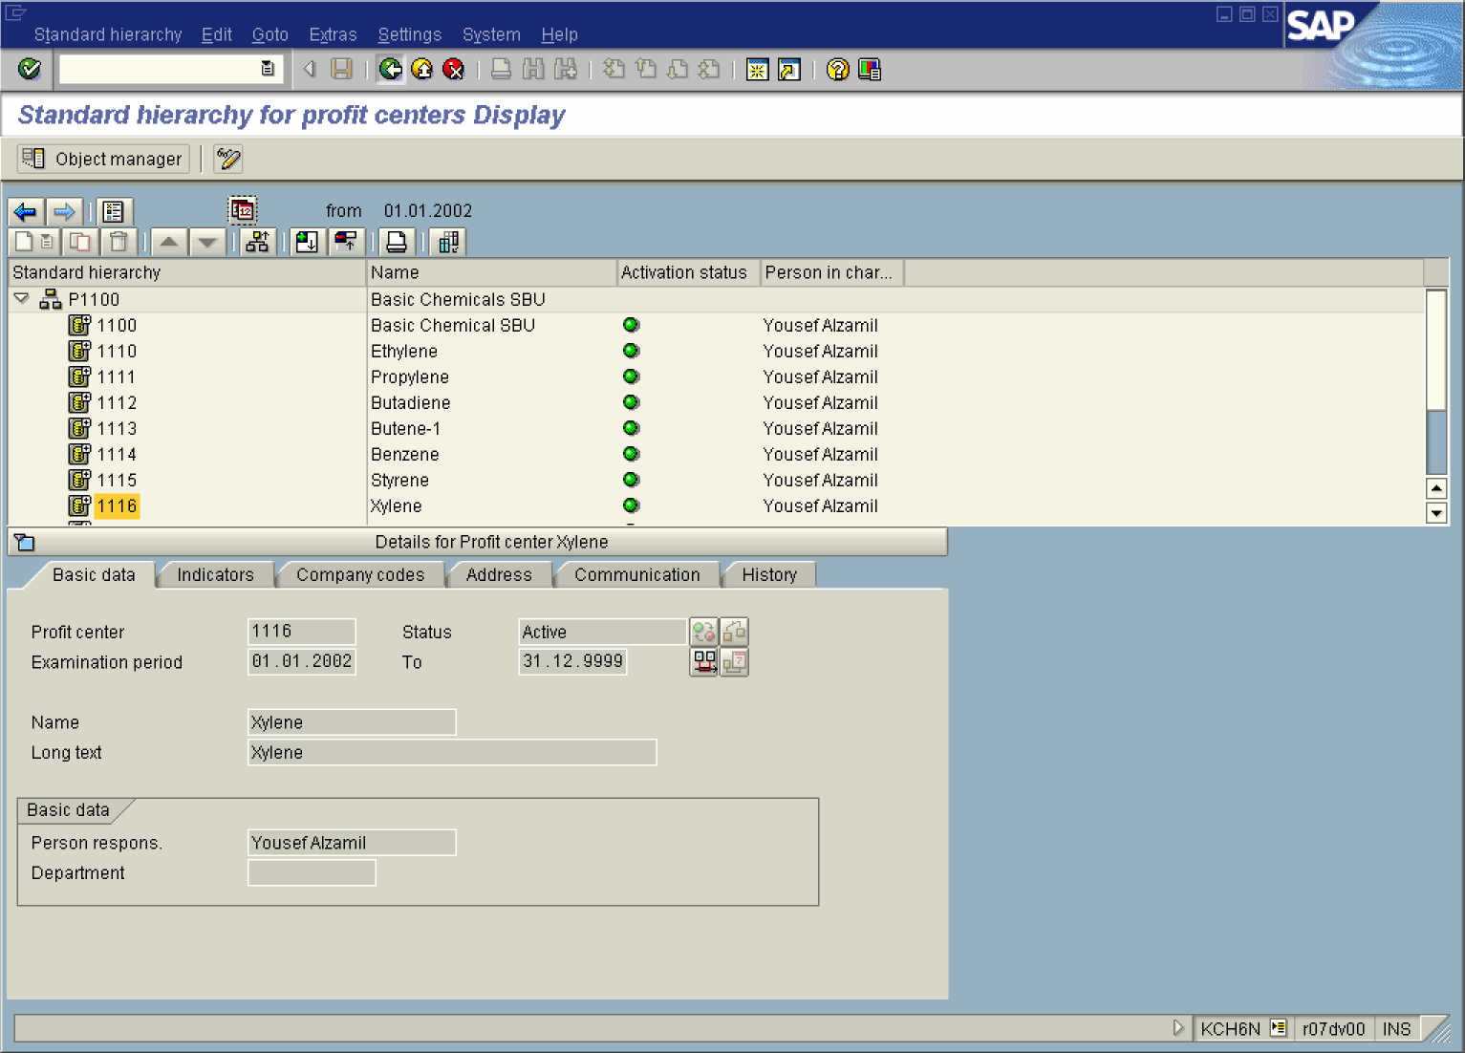

11. Click Back .

